Inactive/Active Tool User Guide

1. When entering website of “Test Case Migration Tool”, you should log in the system with domain credentials for authentication.

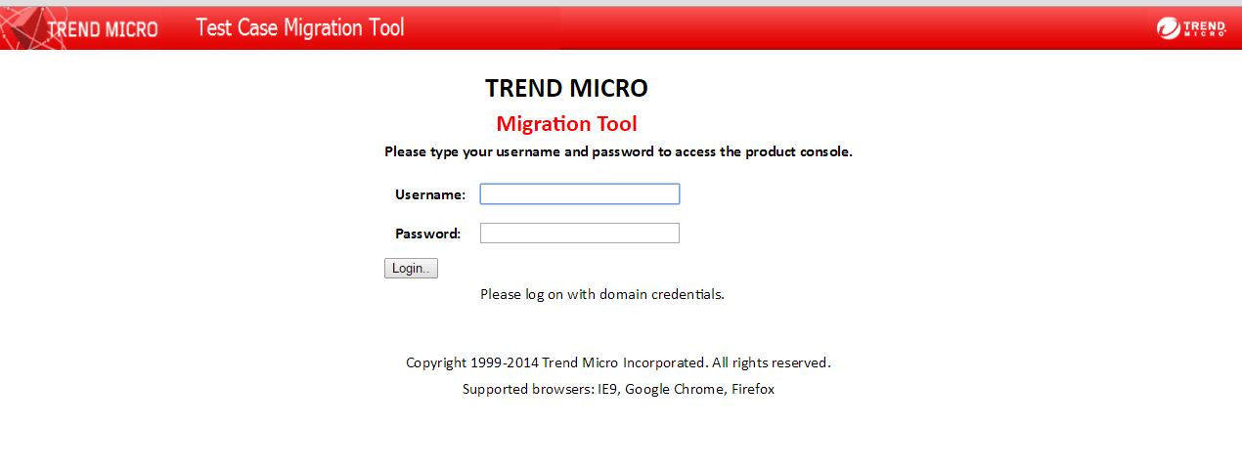

2. After logging in successfully, click the button “Go to Inactive”

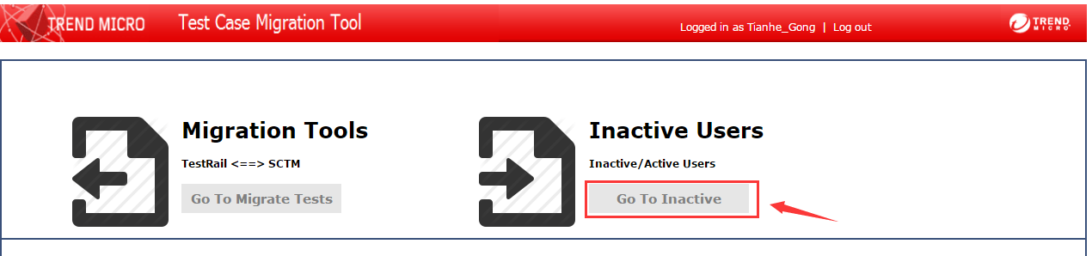

3. When entering “Inactive Users”, the next interface is shown.

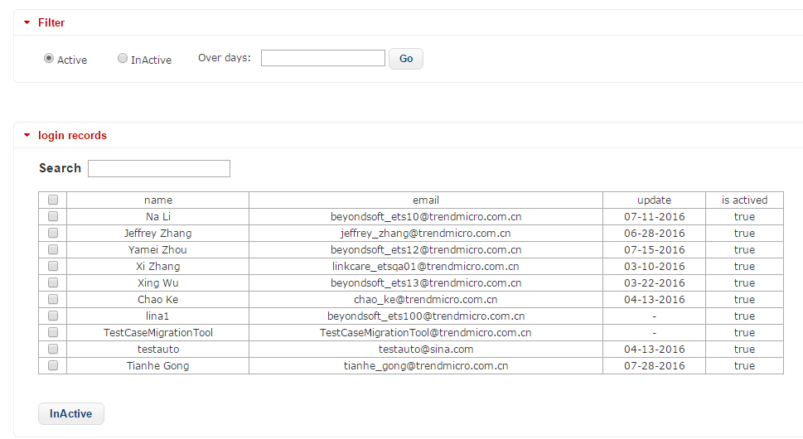

In the first tab “login records”, the accounts of TestRail are presented. If you want only active/inactive accounts are shown, the radios “active” and “inactive” in “filter” can be used. And if you prefer to consult accounts over a certain amount of days, you can type it in the text view in “filter” and press button “go”. You will find that the result is filtered.

If you want to search some account, you can type part of his/her username in the text view beside “Search”. Only the searched results are shown in table when typing.

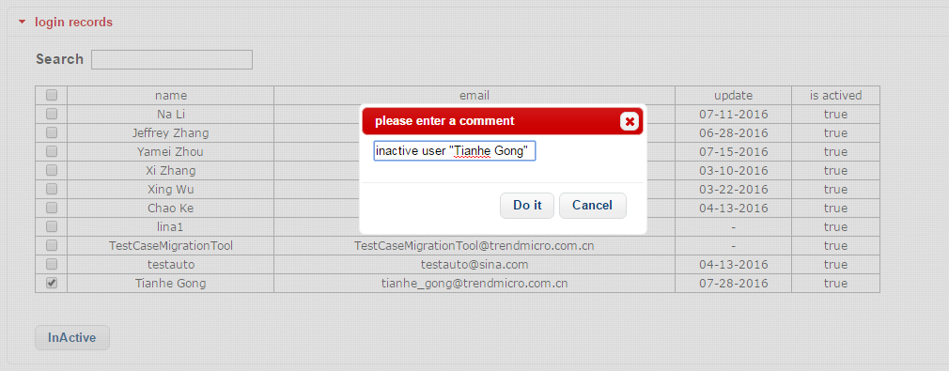

You can choose accounts, and click “Inactive” button (the button becomes “Active” when radio “Inactive” is selected) to inactive them in TestRail system. After clicking the button, a comment is required to be written and operation will be recorded in server.

4. When click the second tab named “operation records”, the history operation and comments relatively are shown.

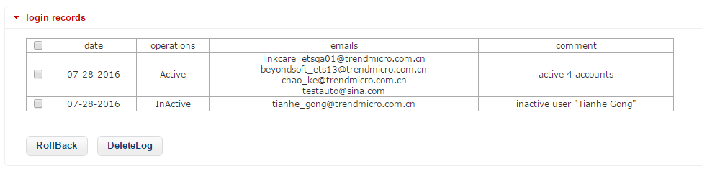

You can click button “RollBack” to roll back some operations if you need to repeal previous operations and a comment is required at the same time. The click “DeleteLog” help you to delete log and clear login records, which cannot be undone.

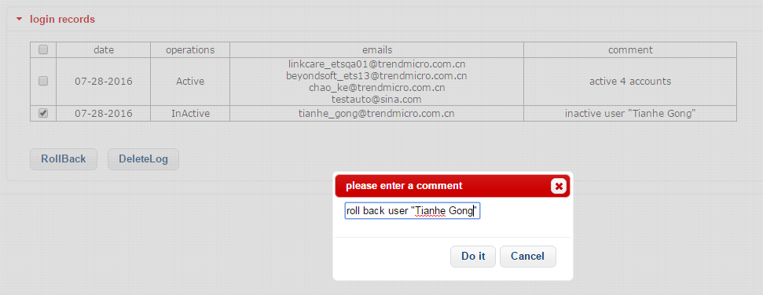

5. You can make system inactive automatically by clicking the third tab.

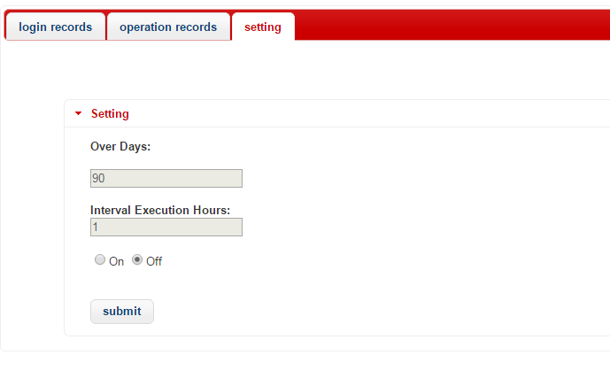

Click radio “On” if you want to turn on this function. And you should set the over days and interval execution hours. For example, if over days is 90 and interval execution hour is 1, system will check all accounts every 1 hour, and inactive those which haven’t been logged in for 90 days.

Click “submit” button to make your settings come into force.

